Wanning Zhu HW1

1. Circuit

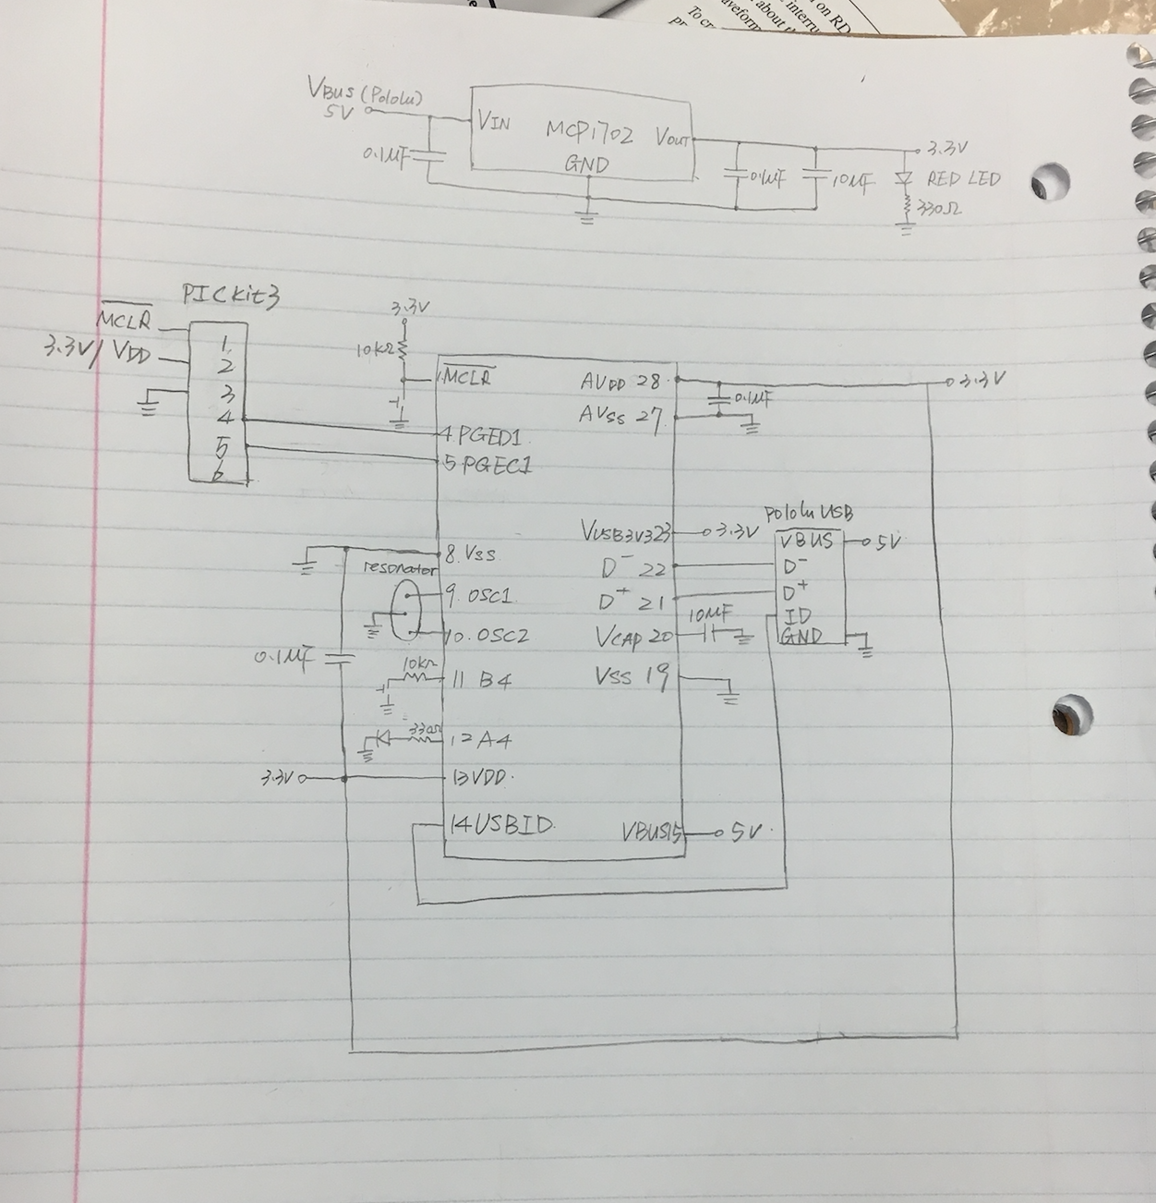

2. 3.3V Oscillation wave

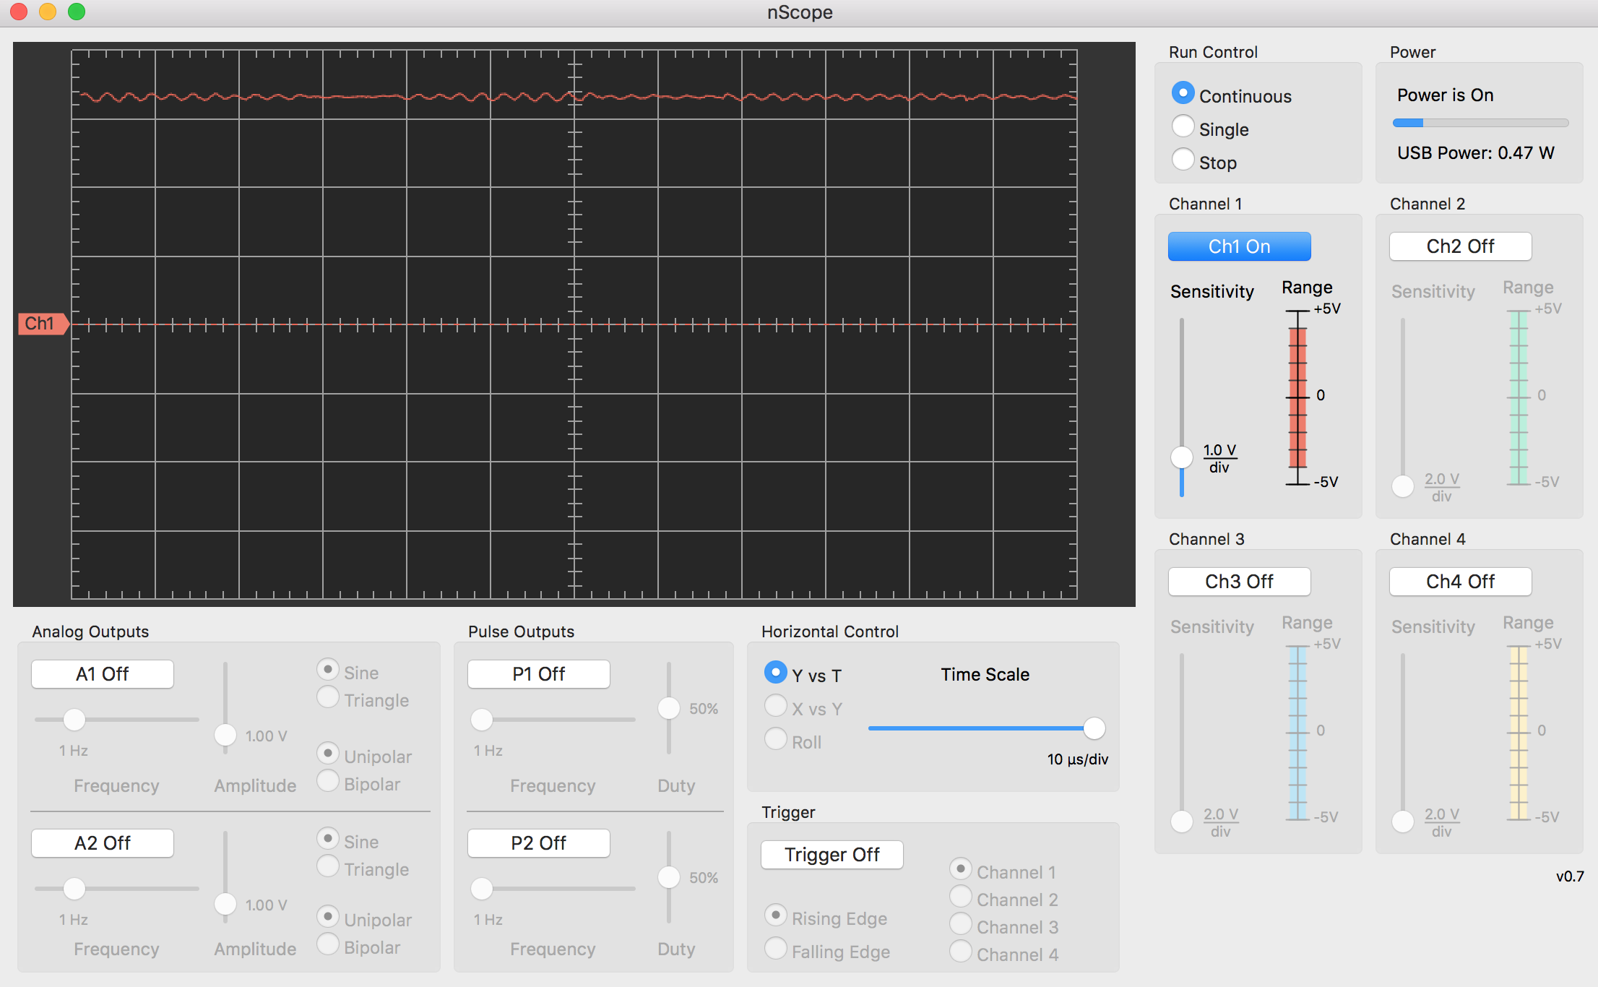

3. 3.3V Clean wave

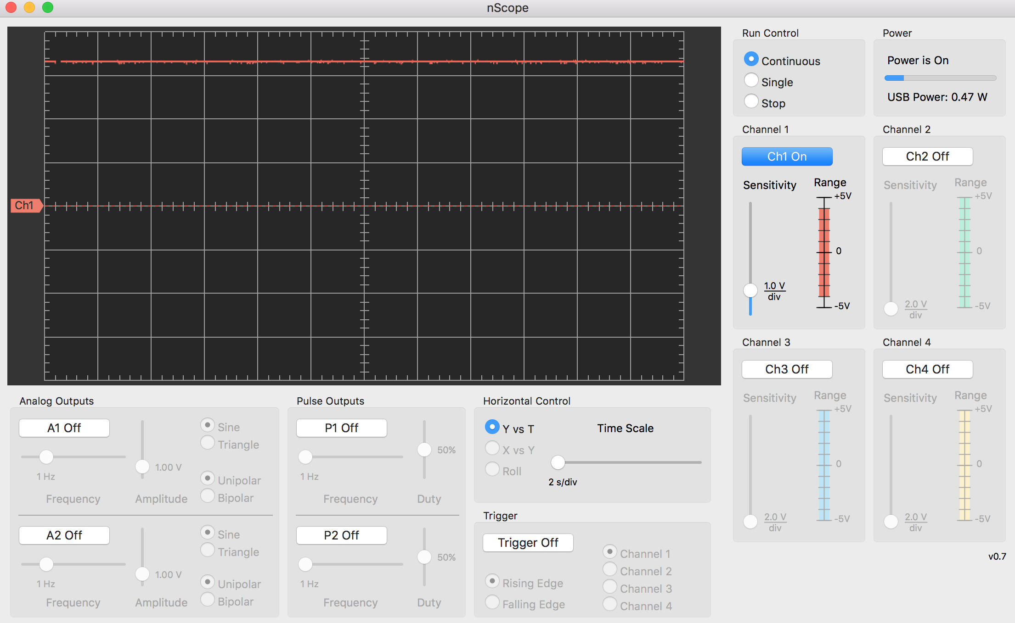

4. Breadboard

